**CHILES MINI MU**

**GEOMETRY – EUROPE**

**ANSWER KEY and SOLUTIONS**

**1) D 11) C 21) D**

**2) A 12) B 22) C**

**3) C 13) D 23) A**

**4) C 14) C 24) E**

**5) B 15) E 25) D**

**6) A 16) E 26) B**

**7) A 17) B 27) C**

**8) A 18) B 28) D**

**9) B 19) A 29) D**

**10) E 20) E 30) B**

**1) D** 8(8)=4(*x*+4); 4*x*+16=64; 4*x*=48; *x*=12

**2) A** Sum of exterior angles is always 360; single exterior angle; thus, one interior angle is 180°-60°=120°. There are 6 interior angles, 6•120 = 720

**3) C** When the 1 inch squares are cut from the corners and fold down the flaps, you have a prism of side lengths 1 (the squares we cut out, the height), 2 (originally 4, two inches removed), and 6 (originally 8, two inches removed). Volume of the air inside is 1•2•6=12

**4) C** Circumference is *C*=*π*•*d; C= π*•2•*π =* 2*π*²

**5) B**

**6) A** Heron's formula:Plugging in gives = = = = 336 km².

**7) A**

**8) A** Radius of 2222 means a diameter of 4444, thus a circumference of 4444π. Half that is 2222π, and subtract the number of sides of a heptagon (7). 2222π-7

**9) B** A is 8, since 4•2=8 and 8•2=16. B is 9, since 3•3=9 and 9•3=27. 9-8=1

**10) E** Logical equivalence means the contrapositive statement. “If p, then q” is logically equivalent to “If not q, then not p.” In context this means “If I did not go to Europe, then you did not get a perfect score.”

**11) C** The number of diagonals in an *n*-gon is (*n*-3) [because you cannot make a diagonal to the adjacent points or the beginning point itself] multiplied by *n* [the number of points to draw diagonals from] all divided by 2 [since a diagonal from top to bottom should not be counted a second time as one from bottom to top.]. Thus *x*=2

**12) B** I'll capitalize for emphasis: desCARTES. Go ahead and take those capitalized letters and ad an -IAN on the end. Voilà.

**13) D** Mu (Μ μ), Alpha(Α α), and Theta(Θ θ) are all Greek letters which roughly translate to the word MATH. The bit about π is another clue.

**14) C** If the radius of the sphere is then the diameter the sphere is . Notice that this is the diagonal of the cube. If you assign a variable *x* to the side length of the cube, you see that the diagonal of one of the faces is and if you use the Pythagorean theorem to solve for the diagonal of the cube you have . It is clear that *x*, our side length for the cube, is equal to 2, and thus the area of the cube is 2*2*2=8

**15) E** 

**16) E** Dividing the side lengths by 400 gives a 3-4-5 right triangle. The measure of the hypotenuse (distance from top of giant to end of shadow) is 2000 in. Answer choice C and D are in meters.

**17) B** The triangle formed has base 5.5 and height 11. Since *A*= 0.5*bh*, plugging in gives .5(5.5)(11) = 30.25

**18) B** 140˚ interior means a 40˚ exterior, since the angles are supplementary. Since the exterior angles always add up to 360, 40*x*=360 → *x*=9 (a nonagon).

**19) A** This is very possible, simply construct perpendicular lines, then construct a 60 degree angles at any arbitrary point on one of the lines. I'll even give a demonstration if I need to; ask for Jason.

**20) E** When n=0, 3 is yielded and when n=1, 5 is yielded, neither of which end in 7. However, when n=2, a 17 is outputted. For n = **an integer** greater than or equal to two, the number ends in 7

**21) D** Side Side Angle is not a way to prove two triangles congruent.

**22) C** If the top radius is half the bottom radius, then the original cone was cut at the half way point. The volume can be found by finding the volume of the original cone, minus the cut off section. Thus we have

**23) A** Using properties of 30-60-90 triangles, the height of the parallelogram is; Then use pythagorean theorem to find the diagonal is(see picture)

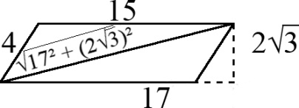

**24) E** If a polygon has 36° exterior angles, it has 10 sides, *a*=10 ; = = *b*; Thus, . Since that's the smallest angle, and the other known one is 90, the remaining one must be 50

**25) D** Let's solve for *v* first. *v*³ +6=1337; *v*³ =1331; *v*=11. Now find 41*v*, which is 451.

**Continued on next page**

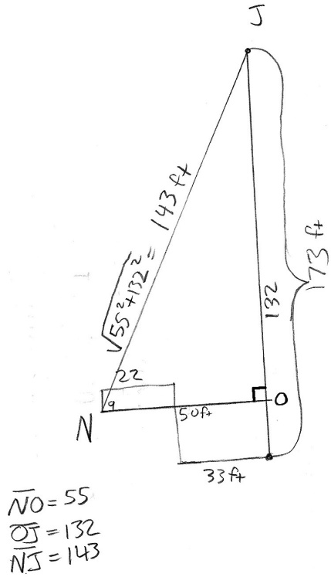

**26) B** (Picture above) He ends up being 143 feet away from Jimmy (note that this is a 5-12-13 triangle, and that 143 is 13•11). He walks in a straight line towards Jimmy at 5.5 feet per second, meaning that in two second he goes 11 feet. There are 13 segments of 11 feet on his journey, and each one takes 2 seconds, thus 13•2=26 seconds. I asked for it in minutes, so your final answer should be which reduces to.

**27) C**

**28) D** Arithmetic mean is greater than the geometric mean, unless all terms to be averaged are equal, in which case the averages are equal. AM≥GM≥HM (Harmonic Mean; for)

**29) D** If O is not next to you, then you cannot be standing on L or R, and if L is not next to you then you cannot be standing on G or O, thus you must be standing on point Y.

**30) B** When *x*=1−1+1−1+1−1+1−..., multiplying by -1 will give −*x*= −1+1−1+1. Substituting into the second step gives *x*=1−(−(−1+1−1+1)). Distributing will yield the original statement, rendering all further operations false, null, and void.